Mr. Standifer
Master Student Notes Rocks
Objectives
-Students will be able to define and describe the 5 characteristics of Minerals.
-Students will be able to differentiate between a mineral and a rock.
-Students will be able to identify specific minerals based on their physical characteristics.
-Students will be able to describe how we obtain economically valuable minerals from the Earth’s crust and compare the benefits to the environmental consequences.
Mineral Characteristics
- A ______________ is
  - naturally occurring
    - formed by natural processes
  - Inorganic
    - Never living, never will be
  - Solid
  - Specific chemical composition
  - Definite crystalline structure.
- Earth’s crust is composed of about 3000 minerals.
- Atoms in minerals are arranged in geometric patterns that are repeated again and again.
- A ________________ is a solid in which the atoms are arranged in repeating patterns.
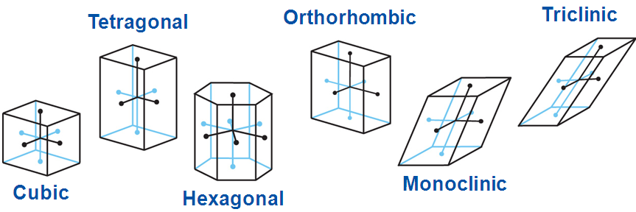

Minerals form in 2 ways

From Magma
- Small crystals form from rapidly cooling magma.
- Large crystals form from slowly cooling magma.

From Solution
- If a solution becomes supersaturated, or overfilled, with another substance, mineral crystals may begin to precipitate, or drop out of solution.
- When liquid evaporates the element remains and begins crystallize.

Mineral Groups
- About 30 minerals are common in Earth’s crust.
- Called “rock-forming minerals” because they make up most of the crust.
- The vast majority of minerals are made up of the eight most common elements.
- Most minerals are formed from the eight most common elements in Earth’s crust.
- Silicates
- Silicates contain silicon, oxygen, and one or more other elements.
- make up 96 percent of minerals in Earth’s crust.
- Most common: feldspar and quartz

- Carbonates
- composed of one or more metallic elements with the carbonate compound CO₃.
- the primary mineral found in rocks such as limestone and marble.

- Oxides
  - compounds of oxygen and a metal.
  - Hematite (Fe₂O₃) and magnetite (Fe₃O₄) are common iron oxides and good sources of iron.
Mineral Identification

- Geologists use several simple tests to identify minerals.
- Tests are based upon a mineral’s physical and chemical properties.

Six Mineral Identification Tests

- Color is one of the least reliable clues to a mineral’s identity
  - trace elements or compounds within a mineral can change its color.
- Luster is the way that a mineral reflects light
  - is described as either metallic or nonmetallic.

- Texture describes how a mineral feels.
  - Texture can be described as smooth, rough, ragged, greasy, soapy, or glassy.

- Streak is the color of the fine powder of a mineral obtained by scratching or rubbing against a hard white surface.
  - Sometimes, a mineral’s streak does not match the mineral’s external color

- Hardness is a measure of how easily a mineral can be scratched.
- one of the most useful and reliable tests for identifying minerals.

- Cleavage & Fracture - Minerals break along planes where atomic bonding is weak.
- Cleavage some minerals split easily and evenly along one or more flat planes.
- Fracture is the ability of minerals to break with arclike, rough, or jagged edges.
Special Properties

- Special properties of minerals also can be used for identification purposes.
  - A type of calcite called Iceland spar causes light to be bent in two directions, a process known as double refraction, when it passes through the mineral.
  - Calcite (CaCO₃) fizzes when it comes into contact with hydrochloric acid (HCl).
  - Magnetite, an iron ore, is naturally magnetic.
  - The mineral sphalerite produces a distinctive rotten-egg odor when it is rubbed vigorously across a streak plate.

PART TWO ROCKS
-Students will demonstrate an understanding of the Rock cycle and all of the processes that cause a rock to change from one type of rock to another.
-Students will be able to define and describe how igneous rocks form and identify several examples of Igneous rocks.
-Students will be able to define and describe how sedimentary rocks form and identify several examples of Sedimentary rocks.
-Students will be able to define and describe how fossil fuels form and evaluate the methods used to extract them.
-Students will be able to define and describe metamorphic rocks and identify several examples of metamorphic rocks.

What are igneous rocks?
- ___________________ are rocks that are formed from the crystallization of magma.
- _____________ is magma that flows out onto Earth’s surface.

Types of Igneous Rocks
- ____________ - fine-grained igneous rocks that cool quickly on Earth’s surface.
- _____________ - coarse-grained igneous rocks that cool slowly beneath Earth’s surface.
  - Granite is the most common intrusive igneous rock.
- The longer a igneous rock can cool the more crystals it will grow inside. Magma deep in the Earth will cool slower versus lava that has poured out on the surface.

Origins of Magma

Factors That Affect Magma Formation
  - Pressure increases with depth as a result of the weight of overlying rock.
  - As pressure increases, melting point increases.

  - Rocks and minerals often contain small percentages of water.
  - As water content increases, the melting point decreases.
How Rocks Melt
Partial Melting
- Not all parts of a rock melt at the same time.
- Some minerals remain solid while others become liquid.
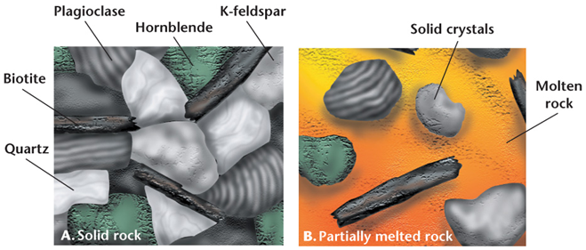
- If temperatures are not great enough to melt the entire rock, the resulting magma will have a different chemistry from that of the original rock.

- This is one way in which different types of igneous rocks form.
Fractional Crystallization
- When cooling starts, magma crystallizes in reverse order
- first minerals to re-crystallize are the last minerals to melt during partial melting.
- __________________________ is the process wherein different minerals form at different temperatures.
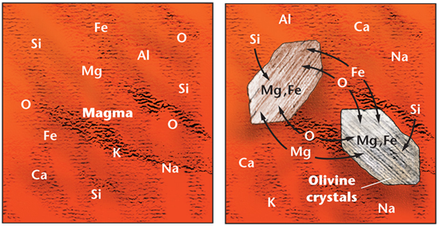
Classifying Igneous Rocks
- Intrusive/Extrusive Igneous rocks are classified according to their mineral compositions and their textures (what kind of crystals they form example extrusive vs intrusive types)
3 main groups of igneous rock
- _______________
  - Example: granite
  - light-colored
  - high silica contents.

- _________________ rocks, such as gabbro, are dark-colored, have lower silica contents, and are rich in iron and magnesium.
- _________________________, such as diorite, have some characteristics of both felsic and mafic rocks.
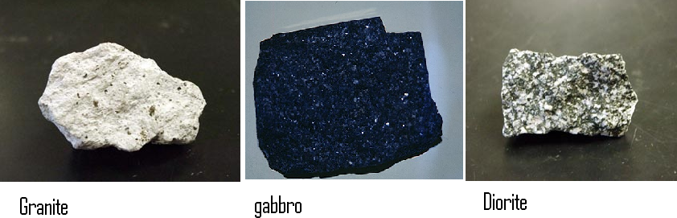
Igneous Rocks as Resources
- Especially useful as building materials.
  - Kitchen counter tops (Granite)
  - Monuments and Statues
Why?
- Interlocking grain textures give them strength.
- Many minerals in igneous rock are resistant to weathering.

Ore Deposits
Veins
- gold, silver, lead, and copper - metallic elements that are not common minerals.
- Precious metals are released at the end of magma crystallization
  - Fluid fills cracks and voids in surrounding rock allowing large crystals to form.
- This fluid solidifies forming metal-rich quartz veins, such as gold-bearing veins.

Formation of Sedimentary Rocks
- ________________________ - pieces of rock left behind by weathering:
  - Wind
  - Water
  - Ice
  - Gravity
  - Chemical precipitation
- When sediments become cemented together, they form sedimentary rocks.
Weathering
- Weathering is physical and chemical processes that break rock into clastic.
- Clastic describes rock and mineral fragments produced by weathering and erosion; classified according to particle size and shape
  - Chemical weathering - minerals in a rock are chemically changed.
  - Physical weathering – Rocks are broken down into small pieces.

Erosion and Transport
Deposition
- When water/ wind slows down, the largest particles settle out first, then the next-largest, and so on.
- Different-sezed particles are sorted into layers.
- wind usually moves only small grains, sand dunes are commonly made of fine, well-sorted sand.
Burial
- As more sediment is deposited in an area, previous layers are put under increasing pressure and temperature causing lithification.
- ______________________ - physical and chemical processes that transform sediments into sedimentary rocks.

Lithification
- begins as the weight of overlying sediments forces sediment grains closer together.
- 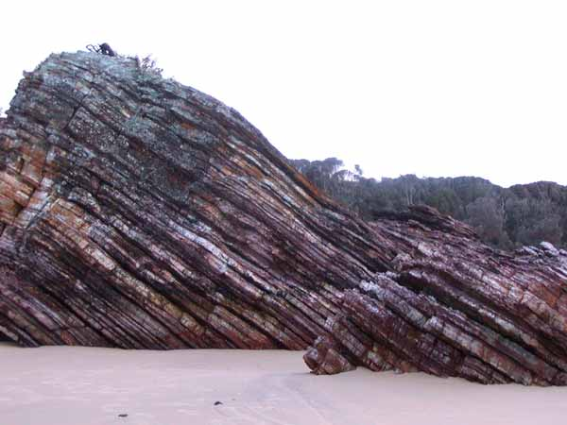
- _________________________ occurs when dissolved minerals crystallize and cement sediment grains together into solid rock.
- Temps in Earth’s crust increase by about 30°C per kilometer.
- Sediments buried 3 to 4 km experience temps. high enough to start the chemical and mineral changes that cause cementation.
Evidence of Past Life
- Fossils only found in sedimentary rocks.
- Fossils are the preserved remains/impressions of once-living organisms.
- Fossils provide
  - evidence of the organisms in the distant past
  - environments that existed in the past
  - how organisms have changed over time.

Types of Sedimentary Rocks
- The classification of sedimentary rocks is based on how they were formed.
- There are three main groups of sedimentary rocks: clastic, organic, and chemical.

Clastic Sedimentary Rocks
- most common type of sedimentary rock
- formed from deposits of loose sediments on Earth’s surface.
- further classified by the sizes of their particles.

Course-Grained Clastics

- Consist of gravel-sized rock and mineral fragments
- Conglomerates have rounded particles; Breccias contain angular fragments.
- Transported by high-energy flows of water.
  - Rock fragments become abraded and rounded as particles scrape against one another.
- The angularity of particles in breccias indicates that the sediments did not have time to become rounded.
Medium-Grained Clastics

- contain sand-sized rock and mineral fragments
- Sandstone forms when these are buried and lithified.
  - high porosity of up to 30 percent.
    - ___________________ % of open spaces between grains.
- Sandstone layers are valuable as underground reservoirs of oil, natural gas, and groundwater.

Fine-Grained Clastics

- Consist of silt and mud siltstone and mudstone.
- Siltstone mostly silt-sized grains
- Shale is mostly silt and clay-sized particles.
  - very low porosity
  - often forms barriers that hinder movement of groundwater and oil.

Chemical Sedimentary Rocks

- During chemical weathering, minerals can be dissolved and carried into lakes and oceans.
- As water evaporates from the lakes and oceans, the dissolved minerals are left behind.
- In arid regions, high evaporation rates can increase the concentration of dissolved minerals in bodies of water.

Rocks Formed from Evaporation

- When the concentration of dissolved minerals in a body of water reaches saturation, crystal grains precipitate out of solution and settle to the bottom.
- _____________________ are the layers of chemical sedimentary rocks that form as a result of the precipitation of crystal grains.
- Evaporites most commonly form in arid regions, in oceans and in drainage basins on continents that have low water flow.
- The three most common evaporite minerals are calcite (CaCO₃), halite (NaCl), and gypsum (CaSO₄).

Organic Sedimentary Rocks

- Organic sedimentary rocks are formed from the remains of once-living things.
- The most abundant organic sedimentary rock is limestone, which is composed primarily of calcite.
- Calcite comes from the calcium carbonate that some organisms use to make their shells.
- Calcium carbonate precipitates out of the water and crystallizes between the grains of carbonate sediment to form limestone.
- Limestone is common in shallow water environments.
- Another type of organic sedimentary rock, coal, forms from the remains of plant material.
- Over long periods of time, thick layers of vegetation slowly accumulate in swamps and coastal areas and are buried and compressed.
- Coal is composed almost entirely of carbon and can be burned for fuel.

Importance of Sedimentary Rocks

- The characteristic textures and features of sedimentary rocks provide a geologic “snapshot” of surface conditions in Earth’s past.
- By considering all of this information, geologists can better understand how geologic changes occur over time.

Energy Resources
- The study of sedimentary rocks has great practical value because many of the natural resources used by humans come from sedimentary rocks.
- Oil, natural gas, coal, uranium, phosphate, and iron are found in sedimentary rocks.
- Limestone is processed to make cement for the construction industry.
- Sandstone and limestone are often cut into blocks for use in walls and buildings.

Causes of Metamorphism

- Metamorphic rock forms when high temperature and high pressure alter: __________________________________. This changes the;
  - Texture
  - Type of minerals
  - Chemical composition

High heat comes from inside the Earth
High pressure from:
  - Weight of overlying rock
  - Compressive forces during mountain building

Two Types of Metamorphism
- _______________________________________
- when high temperature and pressure affect large regions crust.
- 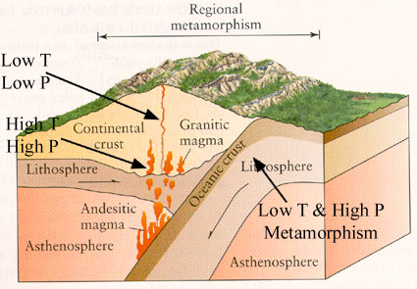
- ________________________________________
- Effects a much smaller area than reg. meta.
  - Rocks in contact with magma are heated.
  - Heated rocks expand resulting in increased pressure
  - 3. Heat and increased pressure causes recrystallization of minerals
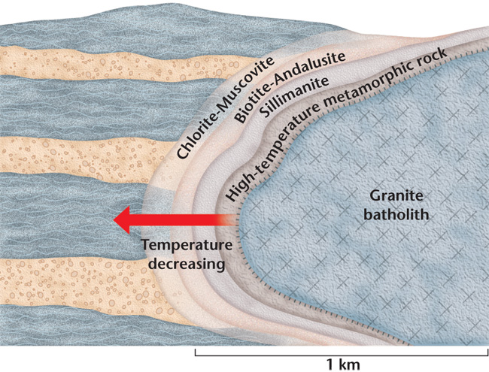
- __________________________________________ occurs when very hot water reacts with rock and alters its chemistry and mineralogy.
- Hydrothermal fluids can
  - dissolve some minerals
  - break down others
  - deposit new minerals.
- Common around igneous intrusions and near active volcanoes especially on the ocean floor.

__________________________________________
- Two textural groups: foliated and nonfoliated.
- Foliated metamorphic rocks are characterized by wavy layers and bands of minerals.
- ________________________ lack mineral grains with long axes in one direction.
- Nonfoliated rock minerals form with blocky crystal shapes.
The Rock Cycle
- Metamorphic rocks are formed by the changing of other rocks.
- Any rock can be changed into any other type of rock.
- The _________________________ is the changing and remaking of rocks.
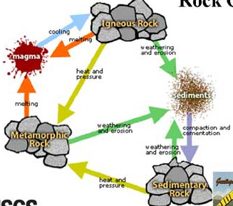
- There is more than one path in the rock cycle.
- The rocks of Earth’s crust are constantly being recycled from one type to another.
- The processes that help shape Earth’s landscapes are also part of the rock cycle.
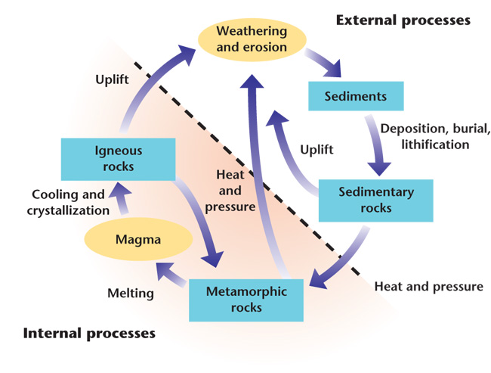
Mining and Mineral Hazards

_____________________________

- Mineral Resource: Any mineral useful to humans
  - Metallic Minerals: Iron Oxide, Gold
  - Non-metallic mineral: Limestone, sand
  - Fossil Fuel; Coal, Petroleum
- Ore: A rock that can be profitably mined for a mineral (often a metal) or for minerals (metals)
  - High Grade Ore; has high concentration of the mineral
  - Low Grade Ore: smaller concentration
- Gangue: Minerals other than ore present in a rock that must be removed.
- Mining and Effects
- Gems are valuable minerals that are prized for their rarity and beauty.

_________________________________

- Extracting these Ores or Gems from the ground can cause many environmental hazards.
- Metals are released into the air during
  - Mining, smelting, refining, Manufacturing and Recycling
  - Air emissions are mostly particulates (small bits that float in the air)
  - Particulates fall out by gravity or wash out by rain
    - These then get into our water, soil, and on vegetation including our crops.

Mining Types

________________________________

- Open pit mines
  - Where large 3D ore body lies close to the surface
  - Leaves a large exposed hole on the surface
  - Exposed rocks prone to weathering and polluting
- Strip mines
  - Mostly for coal where minerals occur in layers paralleling the surface
  - Waste rocks dumped back as spoil banks
  - Newer regulations require reclamation involving grading, restoring, and replanting (explained in more detail in solutions)
  - Can cause changes in topography and drainage (water movement).
  - in US extracts 90% of non-fuel minerals and rocks and 60% of the coal.
  - _____________________ – soil and rock overlying deposit.
  - __________________ – discarded overburden in piles.
  - 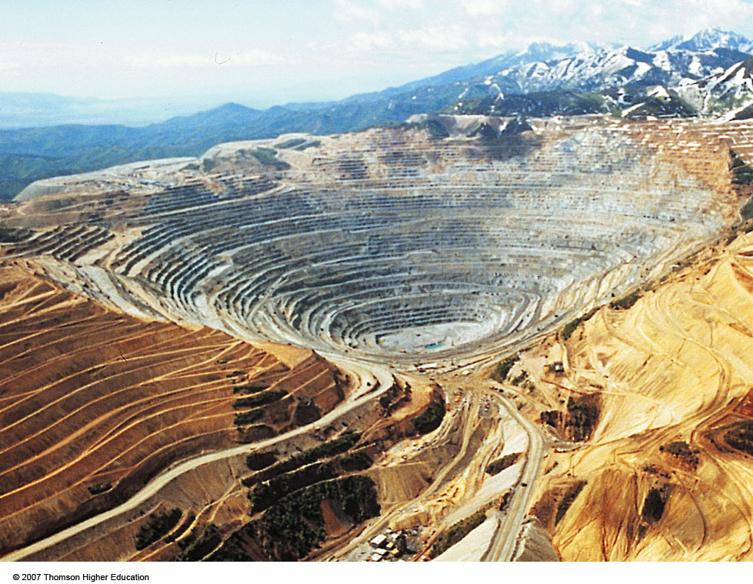open pit
  - 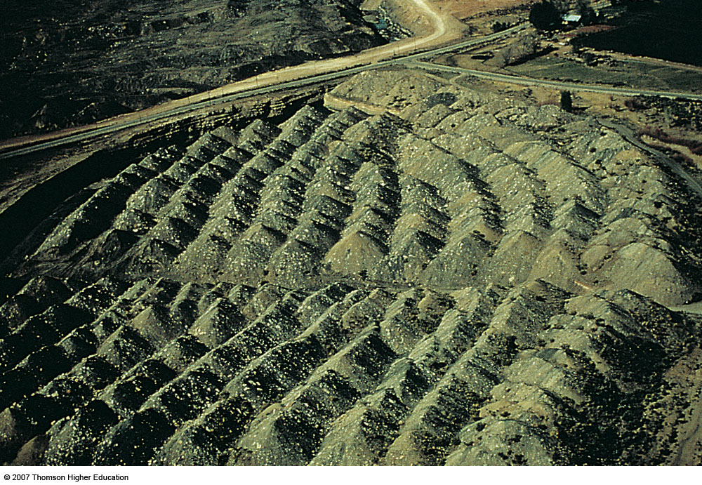spoil banks
  - 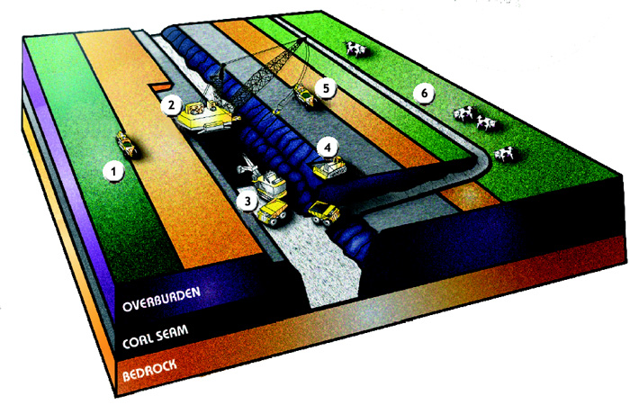strip mining

Subsurface Mining

- Subsurface mining - deposits that are too deep for surface mining
  - Disturbs less land
  - produces less waste
  - but also less effective and dangerous.
  - Most hazardous activity in the US:

Harmful Environmental Effects of Mining

- Waste build up
- Acid Mine Drainage (AMD)
- Heavy Metal Contamination
- Erosion and Sedimentation

Solid Waste
- 75% of our solid waste produced each year in the US is from mining activities. Almost 65 times that of household activities
Acid Mine Drainage (AMD)
- Sulfur in ores react with water and oxygen to form sulfuric acid which leaks out from the mine
- Acid is carried off the mine site by rainwater or surface drainage and deposited into nearby streams, rivers, lakes and groundwater. AMD severely degrades water quality, and can kill aquatic life and make water virtually unusable.
Heavy Metal Contamination & Leaching
- Heavy metal pollution is caused when such metals as arsenic, cobalt, copper, cadmium, lead, silver and zinc contained in excavated rock or exposed in an underground mine come in contact with water.
- Metals are leached out and carried downstream as water washes over the rock surface.
- leaching is particularly accelerated in the low pH (acidic) conditions such as are created by Acid Mine Drainage.

Erosion and Sedimentation
- Mineral development disturbs soil and rock in the course of constructing and maintaining roads, open pits, and waste impoundments.
- erosion of the exposed earth may carry substantial amounts of sediment into streams, rivers and lakes.
- Excessive sediment can clog riverbeds and smother watershed vegetation, wildlife habitat and aquatic organisms.
Four PBT Metals
- PBT: Persistent, Bio-accumulative, Toxic
  - Persistent = stays in environment for a long time.
  - Bio-accumulative= builds up in tissues and often is passed up food chains and magnified towards top predators (like us)
  - Toxic = Damaging to living organisms

Lead

- Affects Nervous system of human fetus and small children
- Most of the lead is stored in bones and along with Calcium, is released in mother’s milk
- Affects IQ, causes delinquency, kidney cancer
- In adults: High BP, affects nervous system and kidney, anemia, infertility

Mercury

- Much of the mercury in the environment originates as mercury vapor from coal burning power plants and incinerators (2-3000 tons)
- Methylmercury biomagnifies up the food chain
  - Some game fish has Hg conc. 200,000 X that of surrounding water
  - Can cause problems to humans eating these fish, particularly among children, old people and pregnant women
- 95% of the exposure comes from eating contaminated fish.
- Toxic to nervous system; A neurological toxin. muscle incoordination, loss of sensation, and difficulties with memory, uncontrolled salivation, tremors.
- Minamata Tragedy:
  - Chisso Corp discharged mercury in Minamata bay from 1930
  - Biomagnification in Fish upto 40 ppm (0.5 ppm safe limit)
  - 200,000 people were poisoned
  - Chronic nervous system damage, miscarriages, deformed fetus
  - Settled in 1996 after 30 years of litigation

Cadmium

- Discovered in 1817, heavily mined since mid-40s
- Bioaccumulates in kidney – increases with age
- Affects include chronic bronchitis and emphysema, kidney effects including kidney stones, and result in kidney failure. Bone problems are usually like osteoporosis or other bone-growth diseases. The cancers cadmium can cause include lung cancer, prostate cancer, and kidney cancer.
- Sources:
  - Mining and smelting of Zn, Pb, Cu
  - Coal burning
  - Phosphatic fertilizers, sewage sludge
  - Nicad batteries: a major source in Municipal Solid Waste

Arsenic

- Metal smelting of Copper and Lead
- Used to be common weed killer
- Emitted by volcanoes as well
- Naturally present in soil
  - Major environmental problem in Bangladesh
- Level in seafoods higher than in land-grown food.
- CCA (Chromated Copper Arsenate) used to treat wood including playground equipments – can contaminate soil
- Causes Cardiovascular damage, “corns and warts” form on feet, hands, and torso. Darkening of skin including Blackfoot disease which is loss of circulation and eventual gangrene.

Solutions
- One way to reduce the hazards of mining is to mine less in the first place. We can accomplish this by;
  - Wasting minerals less a concept we’ll look into more detail later we call Reduce. This includes buying items that use less materials and last longer or not buying things we really don’t need in the first place.
  - Reuse is similar to reducing when we can use the same product over and over again instead of having to purchase new ones that would use more mineral resources and cause more mining.
- Recycling is a solution where instead of discarding those products they are collected, remanufactured, and resold keeping those mineral resources in the “loop” and avoiding mining new ones.
- Those three underlined steps above are what the three arrows of the recycling symbol stand for, NOT reduce, reuse, recycle!

Solutions after Mining

- Once we do mine we can use reclamation to minimize the environmental damage.
- ___________________________ is the process of creating useful landscapes that meet a variety of goals, typically creating productive ecosystems from mined land.
  - Waste dumps are contoured to flatten them out, to further stabilize them against erosion.
- Solutions after Mining
- They are covered with topsoil, and vegetation is planted to help consolidate the material.
- If it is an open pit mine then it is then surrounded with a fence, to prevent access, and it generally eventually fills up with groundwater.
- 