Student Notes Plate Tectonics

**Objectives**

- Students will be able to label and describe the layers of the Earth and their physcial characteristics.

- Students will demonstrate understanding of Continental Drift, and the evidence for Continental Drift.

- Students will demonstrate understanding of how the Continental Drift evolves into the Theory of Plate Tectonics.

- Students will demonstrate understanding of how convection currents in the Mantle cause Tectonic plate movement.

- Students will demonstrate understanding of the different types of crustal material (oceanic and continental) and how their interactions shape the Earths surface.

- Students will demonstrate understanding of the causes and geographic features of Tectonic Plate Boundaries: convergent, divergent, transform.

**Vocabulary**

|  |
| --- |
| Continental Drift |
| Earth's Crust |
| Earth's Mantle |
| Earths Core |
| Rift Valley |
| Seafloor spreading |
| Subduction Zone |
| Theory of Plate Tectonics |
| Transform Fault |

**Drifting Continents**

* Earth’s surface appears to remain relatively unchanged during the course of an average human lifetime.
* On the geologic time scale, Earth’s surface is changing at rates almost too great to imagine.

**Early Observations**

* In the late 1500s, Abraham Ortelius, a Dutch mapmaker, noticed the apparent fit of continents on either side of the Atlantic Ocean.
* In the late 1800s, Eduard Suess, an Austrian geologist, hypothesized that the present southern continents had once been joined as a single landmass that he named Gondwanaland.
* The first time that the idea of moving continents was proposed as a serious scientific hypothesis was in 1912 by a German scientist named Alfred Wegener.

**Continental Drift**

* Wegener’s hypothesis, **_____________________**, proposed that Earth’s continents had once been joined as a single landmass.
* Wegener proposed that Pangaeabegan to break apart about 200 million years ago and that the continents had continued to slowly move to their present positions.
* **_________________**, a Greek word that means “all the earth,” refers to the combined landmass.



**Evidence from Rock Formations**

* Wegener reasoned that large geologic structures, such as mountain ranges, would have fractured as the continents separated.
* Using this reasoning, Wegener hypothesized that there should be areas of similar rock types on opposite sides of the Atlantic Ocean.
* That similar groups of rocks were observed in the United States, Greenland, and Europe supported Wegener’s idea.

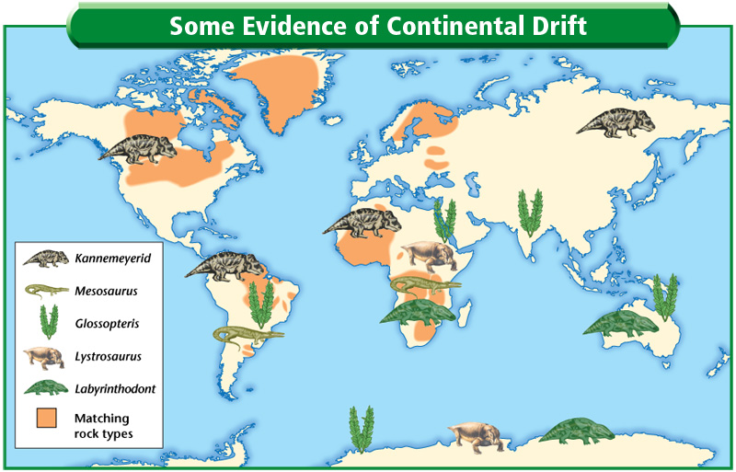

**Evidence from Fossils**

* Similar fossils of several different animals and plants that once lived on land had been found on widely separated continents.
* The ages of different fossils predated Wegener’s time frame for the breakup of Pangaea.
* Fossils of *Glossopteris*, a seed fern that resembled low shrubs, have been found on many continents, indicating that the areas had a single climate that was close to the equator.



**Ancient Climatic Evidence**

* Various sedimentary rocks offer evidence of vast climatic changes on some continents.
* Coal deposits in Antarctica suggested that it must have been closer to the equator.
* Glacial deposits found in Africa, India, Australia, and South America suggested that these areas had once been covered by thick ice caps.
* Wegener proposed that they once were located near the south pole before Pangaea began to fracture.

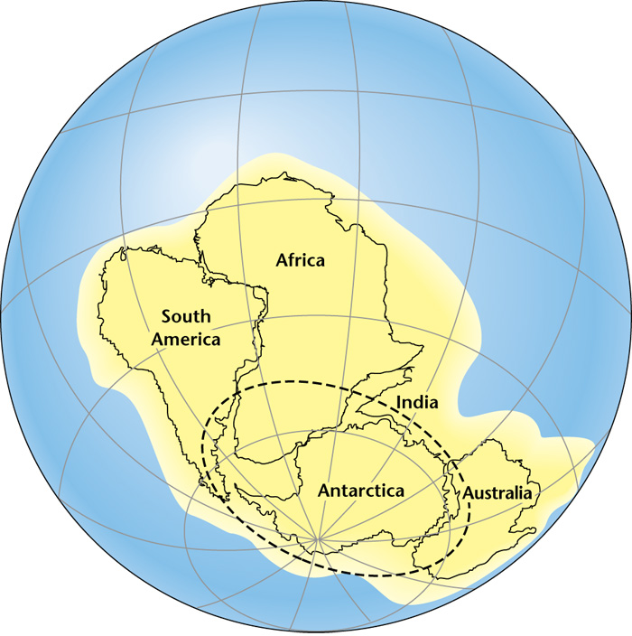

**A Rejected Hypothesis**

* In the early 1900s, most scientists rejected Wegener’s hypothesis of continental drift.
* Two unanswered questions—what forces could move continents and how continents could move without shattering—were the main reasons that the hypothesis of continental drift was rejected.

**Seafloor Spreading**

* Until the mid-1900s, most people, including many scientists, thought that the ocean floor, unlike the continents, was essentially flat.
* Many people also had the misconceptions that oceanic crust was unchanging and was much older than continental crust.
* Advances in technology during the 1940s and 1950s, however, proved all of these widely accepted ideas to be wrong.

**Help from Technology**

* The development of echo-sounding methods allowed scientists to study the ocean floor in   
  great detail.
* Sonar uses sound waves to measure water depth by measuring the time it takes for sound waves to travel from the device and back to a receiver.

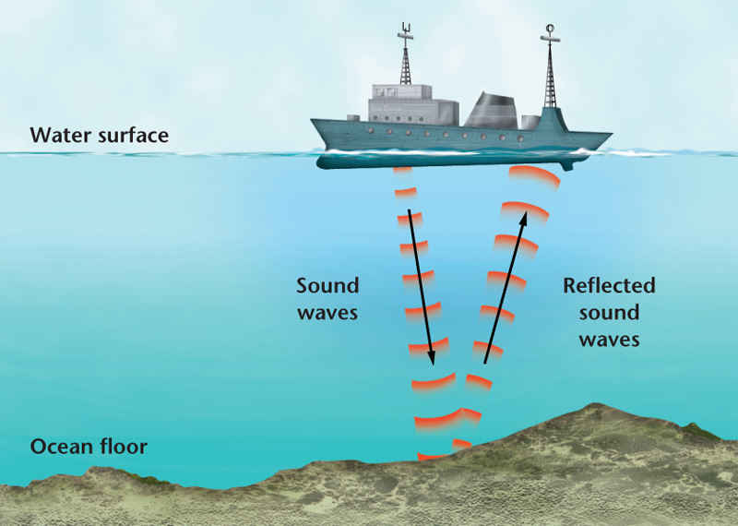

* A **_______________________** is a device that can detect small changes in magnetic fields, allowing scientists to construct magnetic maps of the seafloor.

**Ocean Floor Topography**

* The maps made from the data collected by sonar and magnetometers showed underwater mountain chains called ocean ridges.
* The same data showed that these underwater mountain chains have counterparts called   
  deep-sea trenches.
* These two topographic features of the ocean floor puzzled geologists for over a decade after their discovery.
* Analysis of deep-sea rocks and sediments produced two important discoveries.

**1.** The ages of the rocks that make up the seafloor vary in different places, and that the age of oceanic crust consistently increases with distance from a ridge.

* The oldest part of the seafloor is geologically young at about 180 million years old.

**2.** The thickness of ocean-floor sediment was, in general, much less than expected and that the thickness of the sediments increases with distance from an ocean ridge.

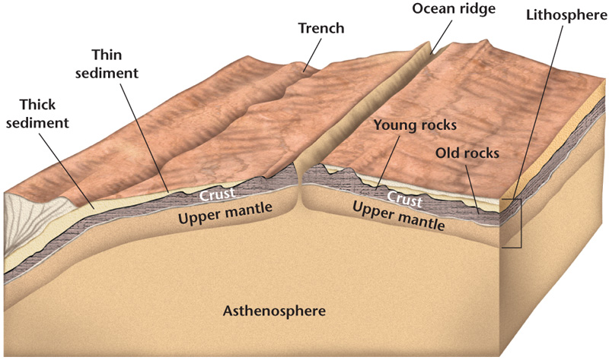

**Magnetism**

* Rocks containing iron-bearing minerals provide a record of Earth’s magnetic field.
* Basalt, because it is rich in iron-bearing minerals, provides an accurate record of ancient magnetism.
* Studies of continental basalt flows in the early 1960s revealed a pattern of magnetic reversals over geologic time.
* A **_________________________** is a change in Earth’s magnetic field.
  + A magnetic field that is the same as the present has normal polarity.
  + A magnetic field that is opposite to the present has reversed polarity.

**Magnetic Symmetry**

* The positive and negative areas of the seafloor form a series of stripes that were parallel to ocean ridges.
* The magnetic pattern on one side of the ridge is a mirror image of the pattern on the other side of the ridge.

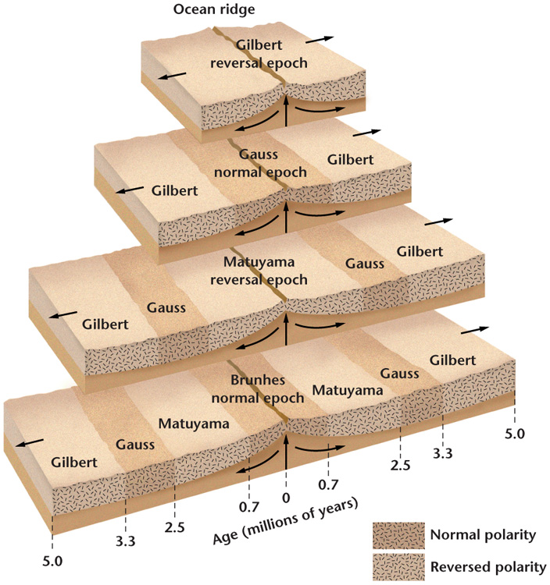

* The magnetic data collected from the ocean floor matched the pattern of magnetic reversals that had been found in basalt flows on land.
* From this match, scientists were able to determine the age of the ocean floor from a magnetic recording and quickly create isochron maps of the ocean floor.
* An **____________________** is a line on a map that connects points that have the same age.

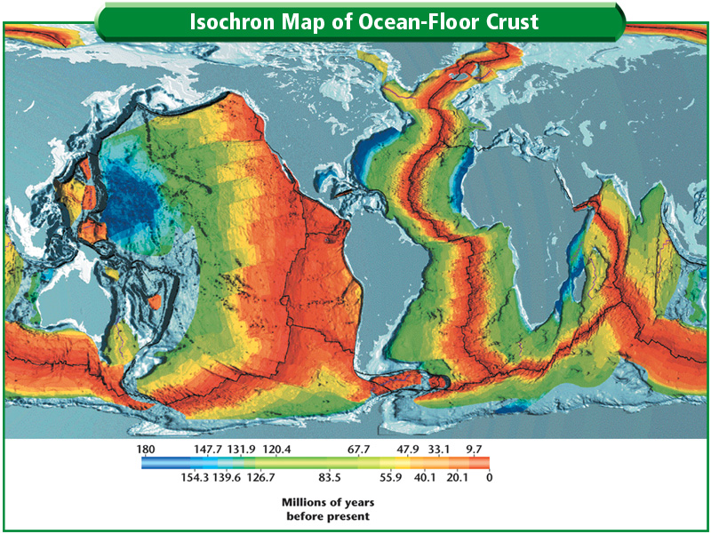

**Seafloor Spreading**

* An American scientist named Harry Hess proposed the theory of seafloor spreading.
* **__________________________** states that new ocean crust is formed at ocean ridges and destroyed at deep-sea trenches.
* Magma is forced toward the crust along an ocean ridge and fills the gap that is created.
* When the magma hardens, a small amount of new ocean floor is added to Earth’s surface.
* Each cycle of spreading and the intrusion of magma results in the formation of another small section of ocean floor, which slowly moves away from the ridge.



**The Missing Link**

* Seafloor spreading was the missing link needed by Wegener to complete his model of continental drift.
* Continents are not pushing through ocean crust, as Wegener proposed; they ride with ocean crust as it slowly moves away from ocean ridges.

**Theory of Plate Tectonics**

* The theory of plate tectonics states that Earth’s crust and rigid upper mantle are broken into enormous moving slabs called plates.
* There are a dozen or so major plates and several smaller ones.
* Tectonic plates move in different directions and at different rates over Earth’s surface.

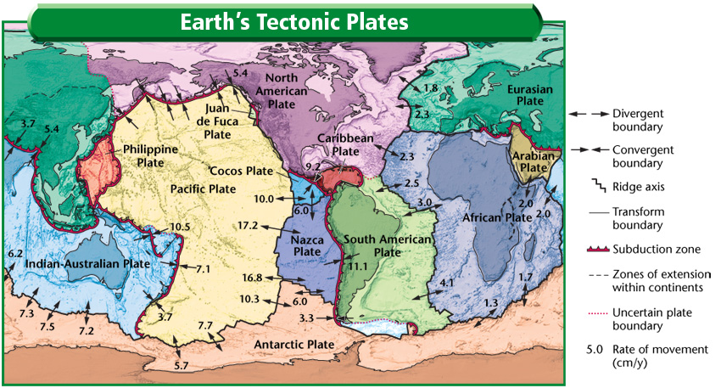

**Plate Boundaries**

* Tectonic plates interact at places called plate boundaries.
* At some plate boundaries:
  + Plates come together, or converge
  + Plates move away from one another, or diverge
  + Plates move horizontally past one another

**Divergent Boundaries**

* **________________________** are places where two tectonic plates are moving apart.
* Most divergent boundaries are found in rifts, or fault-bounded valleys, which form along the axis of an ocean ridge.
* A **_______________________,** which is a narrow depression, is created when a divergent boundary forms on a continent.
* 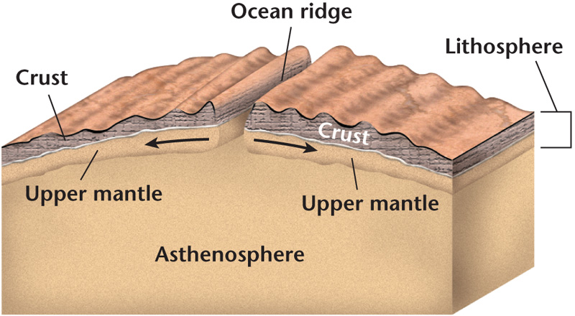

**Convergent Boundaries**

**______________________** are places where two tectonic plates are moving toward each other.

* There are three types of convergent boundaries:

**1.** Oceanic crust converging with oceanic crust

**2.** Oceanic crust converging with continental crust

**3.** Continental crust converging and colliding with continental crust.

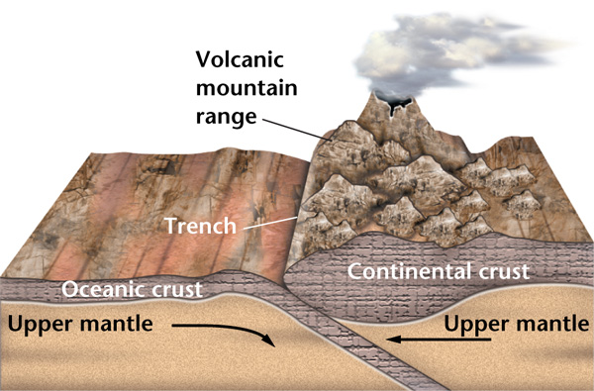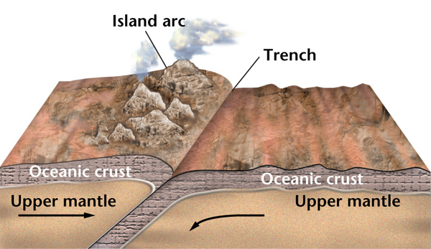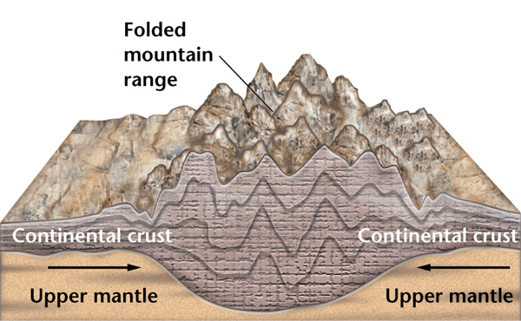

* **_________________________** occurs when one of the two converging plates descends beneath the other.
* A subduction zone forms when one oceanic plate, which has become denser as a result of cooling, descends below another plate creating a deep-sea trench.
* The subducted plate descends into the mantle and melts.
* Some of the magma forms new oceanic crust at the ridge or is forced back to the surface, forming an arc of volcanic islands that parallel the trench.
* When an oceanic plate converges with a continental plate, the denser oceanic plate is subducted.
* Oceanic-continental convergence produces a trench and a series of volcanoes along the edge of the continental plate.
* Because continental rocks are too buoyant to be forced into the mantle, the colliding edges of the continents are crumpled and uplifted to form a mountain range.

**Transform Boundaries**

* A **________________________** is a place where two plates slide horizontally past each other, deforming or fracturing the crust.
* Transform boundaries are characterized by long faults and usually offset sections of ocean ridges.
* The San Andreas Fault is an exception to the fact that transform boundaries rarely occur on continents.

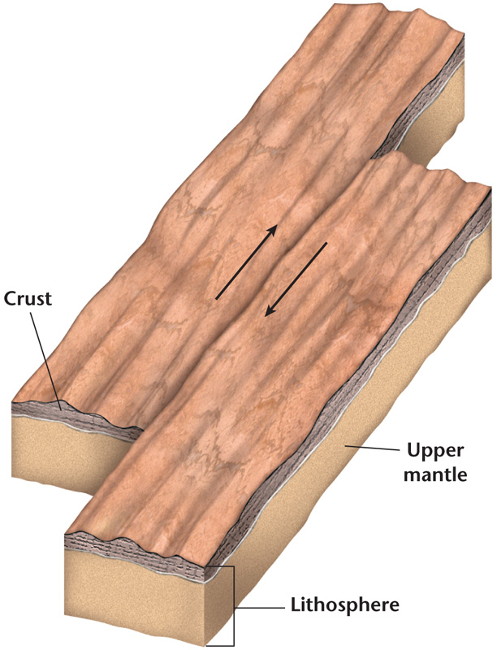

**Causes of Plate Motions**

* The directions and rates of plate movements have been measured.
* What actually causes the plates to move is not well understood.
* One of the leading hypotheses proposes that large-scale motion in the mantle is the mechanism that drives the movement of tectonic plates.

**Mantle Convection**

* Convection is the transfer of thermal energy by the movement of heated matter.
* Convection currents in the mantle are thought to be the driving mechanism of plate movements.
* Convection currents in this part of the mantle are set in motion by the transfer of energy between Earth’s hot interior and its cooler exterior.
* It is hypothesized that these convection currents are probably set in motion by subducting slabs, thus causing plates to move.
* The rising part of a convection current spreads out as it reaches the upper mantle and causes both upward and lateral forces.
* These forces lift and split the lithosphere at divergent plate boundaries.
* The downward part of a convection current occurs where a sinking force pulls tectonic plates downward at convergent boundaries.

**Push and Pull**

* During the formation of an ocean ridge, forces in the mantle cause the asthenosphere to rise.
* In a process called **_____________________**, the weight of the uplifted ridge is thought to push an oceanic plate toward the trench formed at the subduction zone.
* In addition to ridge push, the horizontal flow at the top of a convection current could create drag on the lithosphere and thereby contribute to plate motion.
* A sinking region of a mantle convection current could suck an oceanic plate downward into a subduction zone.
* In a process called **______________________**, the weight of a subducting plate helps pull the trailing lithosphere into the subduction zone.

