Mr. Standifer

**Student Notes Energy Resources**

Types of Resources

* Renewable resources: resources from the Earth that are 1. ______________ (Ex: sunlight, wind, heat)
* Non-renewable resources: resources that cannot be re-grown, or re-made to keep up with the needs of consumers (humans) (Ex: minerals, fossils fuels, trees, drinking water)

Conventional Energy Resources

* **Fossil fuels** are energy sources that formed over geologic time as a result of the compression and partial decomposition of 2.______________________.
* Fossil fuels are considered to be nonrenewable because their formation occurred over thousands or even millions of years.
* Fossil fuels include peat, coal, natural gas, and petroleum.

Net Energy

* **Net Energy Gain** (**NEG**) is a concept used in energy economics that refers to the difference between the energy expended to harvest an energy source and the amount of energy gained from that harvest.

Pollution

* Besides net energy the pollution caused by a power source must also be considered.
* There are two general pollution types.
* Point pollution  is a 3.____________ identifiable source of  air, water, thermal, noise or light pollution
* Nonpoint source pollution generally results from land runoff, precipitation, atmospheric deposition, drainage, or seepage.
* Nonpoint source (NPS) pollution comes from 4._____________________ sources. NPS pollution is caused by rainfall or snowmelt moving over and through the ground. As the runoff moves, it picks up and carries away natural and human-made pollutants, finally depositing them into lakes, rivers, wetlands, coastal waters and ground waters.

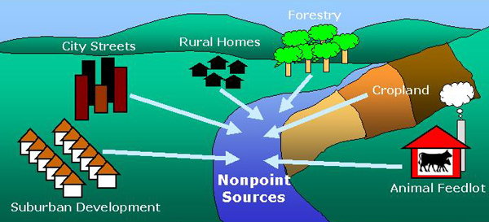

Tragedy of the Commons

* A social dilemma regarding an individual’s responsibility to others; the tragedy of the commons derives from situations in which one player takes more than his/her share of a resource—the 'commons'—which means that all participants will suffer
* Usually when a 5.________________________________________.
* http://www.youtube.com/watch?feature=player_detailpage&v=EZFkUeleHPY

FOSSIL FUELS

**Fossil fuels** are energy sources that formed over geologic time as a result of the compression and partial decomposition of plants and other organic matter.

* Fossil fuels are considered to be 6._______________________ because their formation occurred over thousands or even millions of years.
* Fossil fuels include peat, coal, natural gas, and petroleum.

So how much do we depend on fossil fuels world wide?

* Roughly 87% of the world’s energy comes from fossil fuels.
* A total of 7._______ of the world’s energy comes from non-renewable resources when you count nuclear energy as well.

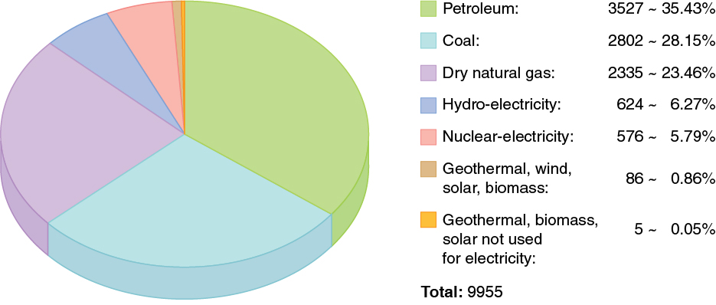

20 richest countries consume:

* 50% of coal
* 80% of natural gas
* 65% of oil

COAL

* Coal is a combustible black or brownish-black sedimentary rock.
* Coal is composed primarily of carbon along with variable quantities of other elements, chiefly hydrogen, sulfur, oxygen, and nitrogen.
* Coal forms when 8.___________________ is converted into peat, which in turn is converted into lignite, then sub-bituminous coal, then bituminous coal, and lastly anthracite.
* This involves biological and geological processes that take place over a long period.
* The stages of coal in decreasing heat value (how much heat they put off) are
  + 9.____________
  + Bituminous
  + Subbituminous
  + Lignite
  + Peat
* Coal is primarily burned for 10.__________________________________ (which is in turn used to heat homes).
* Right now the US and Asia have the largest reserves of coal followed by Russia
* 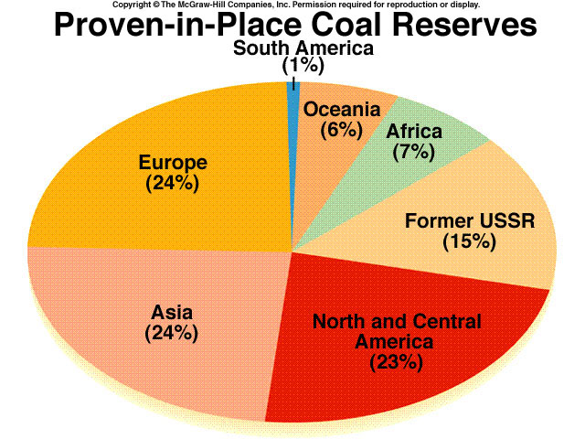
* Coal is the largest source of energy for the generation of electricity worldwide, as well as one of the largest worldwide anthropogenic (man made) sources of carbon dioxide releases.
* In 1999 world gross carbon dioxide emissions from coal usage were 8,666 million tons of carbon dioxide.

Coal mines

There are two types of mining.

What determines the type of mining?

Underground v.s. Surface Mining depends on…

* + Depth of below surface
  + Size of the ore body
  + Shape of the ore body
  + Grade
  + Type of Ore

**Open pit**

* Used when ore bodies lie near the surface
* Large hole exposes the ore body
* Waste rock (overburden) is removed
* 2nd cheapest method, but has the largest environmental impact. Usually because reclamation is impossible for large hole.
* 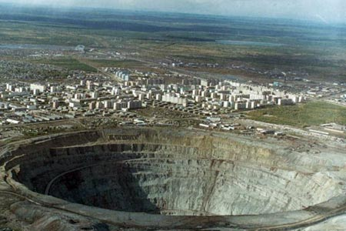

**Strip Mining**

* The cheapest and safest method, but can have a significant impact environmentally on the surface.
* The ore is close to the surface of the land (30m) but has one or more layers of rock and dirt on top of it (11.________________).  To mine the ore, these layers have to be taken off.
* This mining is done in long, narrow strips.  When the ore is done in one strip, the miners begin to create another strip next to it.  The waste, dirt, and rock that they take off of the top of the next strip is put on top of the last one (It is now called 12._______________).
* 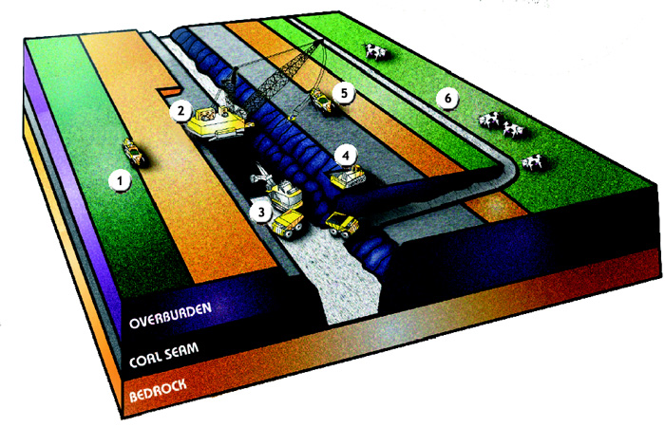

**Underground Mining**

* Very expensive and the most dangerous of the three methods, but has the least impact environmentally on the earth’s surface.
* Underground mining is done when the rocks, minerals, or gemstones are too far underground to get out with surface mining.
* Entry into underground mines is by vertical shafts, or by a sloping tunnel.
* Two common methods of underground mining are ;
* 13.___________________________ where they did out rooms but leave sections behind to hold the roof up
* Long wall mining were a machine shaves veins of minerals off in long patterns and as it moves areas will collapse behind it.
* 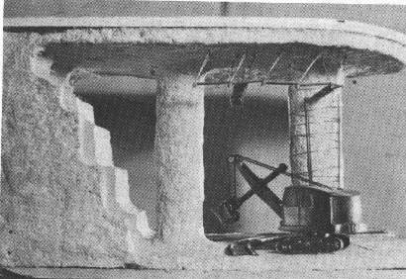

Effects on health

* Virtually all airborne pollutants gain access to the body via the respiratory tract. Thus, it is no surprise that this important system is affected significantly by pollutants discharged into the atmosphere by electrical utilities that burn coal.
* Coal pollutants affect all major body organ systems and contribute to four of the five leading causes of mortality in the U.S.: heart disease, cancer, stroke, and chronic lower respiratory diseases.
* 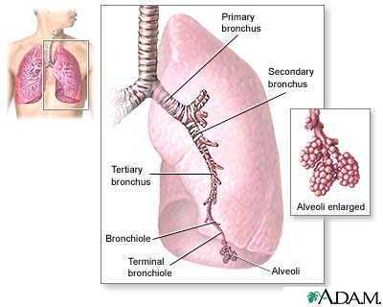
* Air pollutants from coal include nitrous oxide (NO 2) and very small particles, known as PM—adversely affect lung development, reducing forced expiratory volume (FEV) among children (used to determine lung function).
* Air pollution triggers attacks of 14._________________, a respiratory disease affecting more than 9% of all children in the U.S.
* 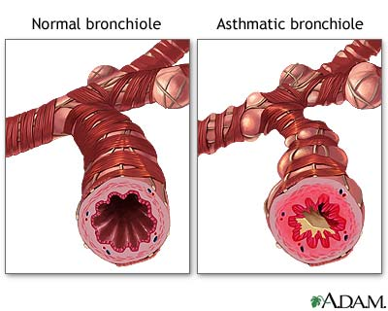
* Pollutants produced by coal combustion damage the cardiovascular system. Coronary heart disease (CHD) is a leading cause of death in U.S.
* The mechanisms by which air pollution causes cardiovascular disease have not been definitively identified but are thought to be the same as those for respiratory disease: pulmonary inflammation and oxidative stress.
* This in turn leads to artery blockages then to heart attacks.
* Tissues die due to oxygen deprivation, including permanent heart damage.
* Coal pollutants also act on the nervous system to cause loss of intellectual capacity, primarily through mercury.
* Coal-fired power plants are responsible for approximately one-third of all 15.___________________________ Emissions.
* A nationwide study of blood samples in 1999–2000 showed that 15.7% of women of child bearing age have blood mercury levels that would cause them to give birth to children with mercury levels exceeding the EPA’s maximum acceptable dose .
* Researchers have estimated that between 317,000 and 631,000 children are born in the U.S. each year with blood mercury levels high enough to impair performance on neurodevelopment tests and cause16.__________________.

Effects on Land

* **17.____________________** is a fine coal refuse and water mixture from a by-product of the coal mining and preparation processes.
* Usually this from a coal preparation plant is stored in a dam. This impounded liquid waste can sometimes total billions of gallons in a single facility.
* High-profile disasters associated with these slurry impoundments have called into question their safety.
* In February 1972, three dams holding a mixture of coal slurry and water in Logan County, West Virginia failed in succession: 130,000,000 US gallons (490,000 m3) of toxic water were released in the Buffalo Creek Flood. Out of a population of 5,000 people, 125 people were killed, 1,121 were injured, and over 4,000 were left homeless. The flood caused 50 million dollars in damages.
* Mountaintop removal
* is a form of surface mining that involves the mining of the summit of a mountain.
* Explosives are used to remove up to 400 vertical feet (120 m) of mountain to expose underlying coal seams. Excess rock and soil laden with toxic mining byproducts are often dumped into nearby valleys.
* Environmental impacts include; loss of biodiversity and toxification of watersheds, that mitigation practices cannot successfully address.

PH scale

* What is the pH scale, what is the range?18.___________________
* What is a log rhythmic scale?19.____________________
* What are the acids, what is bases?20.__________________
* What are most of our foods and most of our cleaners?21._______________

Acid Rain

* What is normal rain water ph?
* Normally around 22._________________
* Why is it so low and not neutral or 7.0?
* Reactions with CO2
* H20 + CO2 -> CO3-2 + 2H+
* So what is acid rain? Anything below normal pH in the area.
* I’ve seen rain as low as 3.5 to 3.0.
* Acid rain is formed when water droplets react with 23._________________ and nitric oxide to form H2SO4 and HNO3.
* Much of our Sulfur dioxide and nitric oxide is released from the burning of fossil fuels especially coal.
* 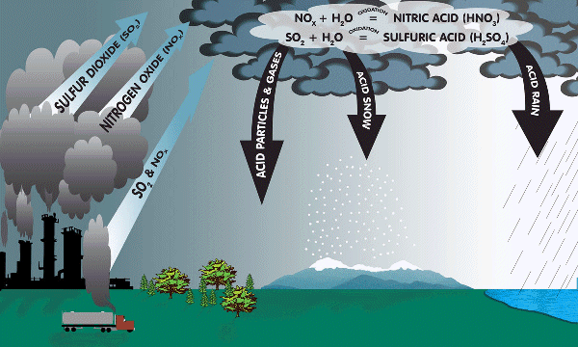
* One of the problems with acid rain is leaching, or the loss of nutrients farther down into the soil. The acids strip the nutrients off the soils and release them into water supplies.
* Thus one way plants are affected by acid rain.
* 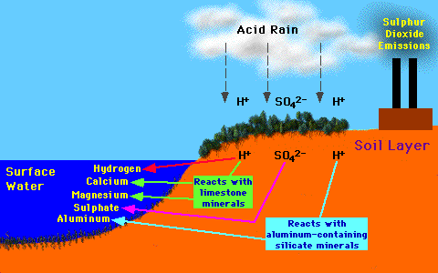

Plant Damage

* Most gaseous pollutants damage leaves directly.
* Long term exposure breaks down the waxy coating that prevents water loss as well as diseases, they are then more susceptible to pests, drought, and frost.
* 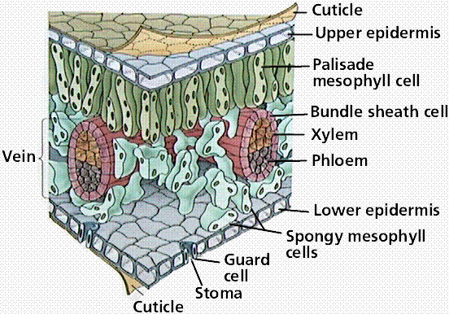
* Such exposure also reduces 24.______________________ by interfering with water and nutrient uptake and leaves turn yellow or brown and drop off.

Coal scrubbers

* A coal scrubber is a pollution-control device primarily installed on coal-fired electricity plants to remove sulfur dioxide (SO2) emissions. Coal scrubbers use limestone or lime to remove sulfur dioxide from the emissions stream.
* 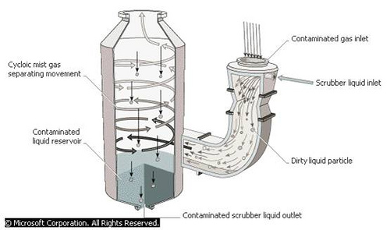

NATURAL GAS

* **Natural gas** is a naturally occurring hydrocarbon gas mixture consisting primarily of 25._______________________.
* Natural gas is an important energy source to provide heating and electricity. It is also used as fuel for vehicles and as a chemical in the manufacture of plastics and other commercially important organic chemicals.
* Methane is actually an odorless and a colorless gas. But if you have smelled natural gas, you have noticed it has a nasty rotten egg smell. Gas companies add a chemical to the gas so it will have this unpleasant smell. The reason for adding this smelly chemical is for our safety. It can be deadly if you breath too much of it. The smell alerts us if there is a natural gas leak.
* Natural gas is found in deep underground natural rock formations or associated with other hydrocarbon reservoirs in coal beds.
* 26. _____________________is also another resource found in proximity to and with natural gas.
* 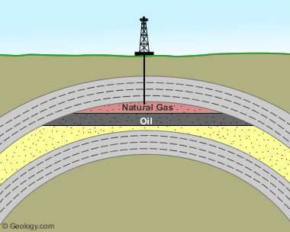
* Advantages of natural gas
  + emits 30% less 27.__________________________ than burning oil and 45% less carbon dioxide than burning coal, thereby, improving the quality of air.
  + natural gas releases very small amounts of sulfur dioxide and nitrogen oxides, and essentially no ash or particulate matter.
  + 60-year supply at current rates
  + 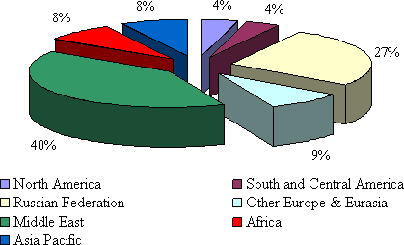
  + combustion of natural gas are carbon dioxide and water vapor. This is exactly what we release when we breathe.

Disadvantages of Natural gas and Fracking

* **Induced hydraulic fracturing** or **hydrofracking**, commonly known as **fracking**, is a technique used to release petroleum, natural gas, or other substances for extraction. This type of fracturing creates fractures from a well drilled into reservoir rock formations.
* A hydraulic fracture is formed by pumping the fracturing fluid into the well at enough pressure to exceed that of the fracture gradient or enough to crack the rock at depth. The rock cracks and the fracture fluid continues further into the rock, extending the crack still further, and so on.
* Operators typically try to maintain "fracture width", or slow its decline, following treatment by introducing into the injected fluid a proppant – a material such as grains of sand, ceramic, or other particulates, that prevent the fractures from closing when the injection is stopped and the pressure of the fluid is reduced.
* The propped fracture is permeable enough to allow the flow of fluids to the well. These fluids include the gas or oil which them can flow out of the rock and into the well to be pumped out.
* Water use - 1-9 million gallons to complete a frack.
* Drilling-waste pits. From 10 percent to 70 percent of the water sent down the well during hydrofracking returns to the surface, and with it drilling chemicals, very high levels of mineral salts and often, naturally occurring radioactive material. Often stored in pit in ground but spills have occurred that make their way to public water sources.
* Water Contamination -- methane contamination is widespread near shale gas drill sites. This means if you have a well near the fracking site your water may contain enough methane in it to light on fire!
* **No federal oversight**. A simple few sentences added to the 2005 Energy Act, indirectly inserted by VP Dick Cheney, known as the “Halliburton Loophole,” exempted hydraulic fracturing operations by oil, gas, or geothermal companies from the 28._______________________________ and the Superfund Act . Meaning industry does not have to disclose any of the names of the thousands, if not millions of gallons of chemicals they pump into the earth each day.

OIL (PETROLEUM)

* A naturally occurring flammable liquid consisting of a complex mixture of hydrocarbons.
* A fossil fuel, it is formed when large quantities of 29.__________________, usually zooplankton and algae, are buried underneath sedimentary rock and undergo intense heat and pressure.
* There are several methods to remove oil from the ground.
* Primary oil just flows into the well by gravity.
* Secondary they pump 30.____________ into a near by well and the oil is forced into the well.
* Tertiary is similar to secondary but high pressure steam is used instead.
* 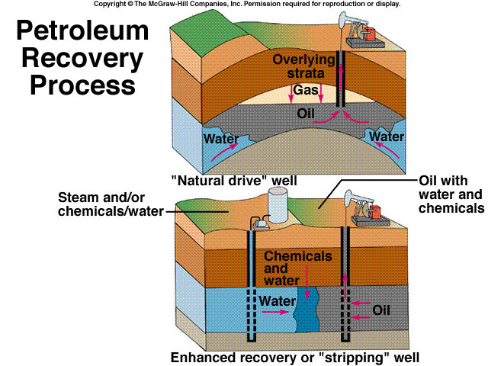
* 31________________________ is our largest consumer of oil.
* The Middle East, specifically Saudi Arabia has the largest reserves of oil left. This has certain security concerns.
* 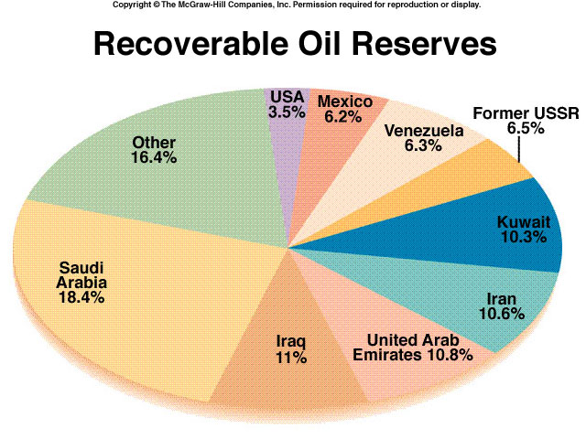
* We are the largest consumer of oil in the world.
* 465 billion barrels consumed
* 1 trillion barrels left
* 22 billion consumed a year
* 45 years to go! Party now!
* Growing use in China (+10%/year)
* Japan, Europe depend on Mideast
* New reserves around Caspian Sea
  + Nearly size of Saudi Arabia
* Increasing source of major wars, human rights abuses

Exxon Valdez, Alaska 1989

* The ***Exxon Valdez* oil spill** occurred in Prince William Sound, 32.________, on March 24, 1989, when the *Exxon Valdez*, an oil tanker bound for Long Beach, California, struck Prince William Sound's Bligh Reef and spilled 260,000 to 750,000 barrels (41,000 to 119,000 m3) of crude oil.
* It is considered to be one of the most devastating human-caused environmental disasters. The *Valdez* spill was the largest ever in U.S. waters until the 2010 *Deepwater Horizon* oil spill, in terms of volume released. However, Prince William Sound's remote location, accessible only by helicopter, plane, and boat, made government and industry response efforts difficult and severely taxed existing plans for response.
* The region is a habitat for salmon, sea otters, seals and seabirds.
* Once oil spills occur they are very difficult to clean up. Generally we use booms to contain spills and skimmers collect the top portion of the water that should contain oil since it is less dense but in rough seas much of it gets mixed downwards.

Fission – Nuclear Reactions

* **Fission:** is a when uranium 235 is 33____________________ into lighter nuclei (elements) when struck by a neutron, each fission releases two or three more neutrons and energy and the cycle can continue.
* Multiple fissions within a critical mass form a **chain reaction**, which releases an enormous amount of energy.
* 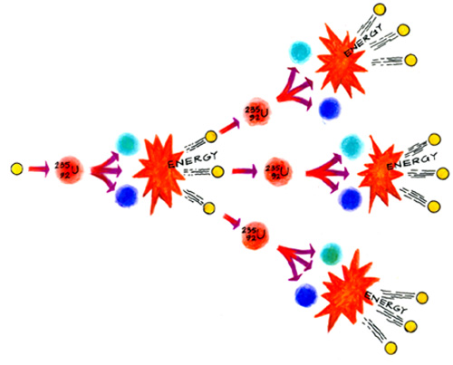
* In a atomic bomb an enormous amount of energy is released in an uncontrolled chain reaction.
* In a nuclear power plant only two or three neutrons released are used to split another nucleus.

Fusion – Nuclear Reactions

* **Nuclear Fusion;** a nuclear change in which two light elements are 34._____ at extremely high temperatures, to form a heavier nucleus and releasing energy.
* Fusion releases more energy than fission but requires extremely high temps such as 1 million C.
* An example a of giant fusion reactor is the sun.
* 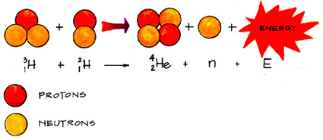

Nuclear Reactors and Fuel Assemblies

* 35.________________________fuel pellets are packed into 12 foot rods.
* About 200 rods are then housed into a fuel assembly.
* A control rod can be moved up or down over the fuel assembly. The control rods absorb neutrons and can control the amount of fission reactions that take place by blocking one fuel assembly from another.

The Core

* A plant may have 250 fuel assemblies in a reactor and then may have 2 or 3 reactors.
* All of this is housed in a reactor vessel and is called the 36._____________.
* Also included in the vessel is the primary cooling system with a coolant usually water.
* This liquid passes by the rods which are releasing heat from the fission reactions and the water can reach extreme temperatures 590 F and is pressured 2250 lbs per square inch.
* High pressure doesn’t allow it to boil thus allowing it to reach higher temperatures.
* The hot coolant runs through a heat exchanger where cool water is poured over the hot primary cooling pipes and the water absorbs the heat and steam is produced which runs through a turbine.
* The steam is then run through a third cooling system with a cooling tower with a condenser.
* 
* Reactors are contained in a containment building that is 3-5 inches thick of steel that can withstand hurricanes, earthquakes and even an airline crash.
* After 3-4 years the rods become too spent or damaged and about 1/3 of it is removed and placed in large concrete lined pools.
* After cooling they could be sent to fuel reprocessing plants or permanent long term storage sites. Not often.

Advantages of Nuclear Power Plants

* No air pollution, only 37.________the carbon dioxide as coal.
* Water pollution and land disturbance are low.
* If built well little chance of catastrophic accidents.

High level Radioactive Waste

* High level waste gives off large amounts of radiation for a short time and low levels for a long time.
* These wastes must be stored for 1,000 of years and 240,000 if P-239 is not removed.
* Mostly 38._________________________.
* Problem is no real solution, no facility will last that long, nor does anyone want the finical and legal responsibility.
* 39. ____________________________________, fused in glass or ceramic sealed in metal containers and buried in salt or granite, that is waterproof and earthquake resistant.
  + Not sound.
  + A proposed site is in the U.S. at the Yucatan Mountain Range in Nevada.
* Another possibility is to shoot the waste into 40.________________.
  + EXTERMELY costly and what if shuttle explodes like challenger.
* Could bury it in Antarctic ice or Greenland ice caps.
  + Long term stability of ice is not known, heat from material could destabilize the ice and retrieval of material would be difficult if method fails.
* Could dump it in deep ocean and41.______________________________.
  + Unknown about ocean bottom, volcanic activity may release material or containers will corrode and retrieval would be impossible.
  + C:\Ogren Docs\APEnviro\nonrenewableenergy\nucpics\nucpics\meltsub.jpg
* Bury it in deposits of mud on the deep ocean floor in areas of geologically stable areas of 65 million years.
* Containers would still corrode and release material, adherence of mud and gravity may contain spill but not known, currently banned.
* Another possibility would be to change it into a harmless isotope, nice idea but not known, with high costs and some disposal still needed. Essentially a nice idea but impossible.