________Points Earned/50 Points Possible ________%

Name: _______________________________________ Date: ______Period:_______
Earth Science Mr. Standifer
Unit 13 – Weather Notes Review

- Changes in our weather are caused by the interactions of _______________________________.

- What is an air mass?

- Describe humidity.

- If a certain volume of air is holding half as much water vapor as it possibly can, what is the relative humidity? ________%

- Complete the following table about the types of air masses: (12 points)

Type of Air Mass | Characterized by... | Causes what type of weather?
Continental Arctic (cA) | Very cold and very dry | Can cause extreme cold waves

- Changes in weather are caused by ____________________________
- What is a front?

- Complete the table about the different types of fronts: (9 points)
Type of Front: | Description: | Weather produced: | Diagram:
Cold | boundary between an advancing cold air mass and the warm air mass it is replacing | severe thunderstorms or snow showers | 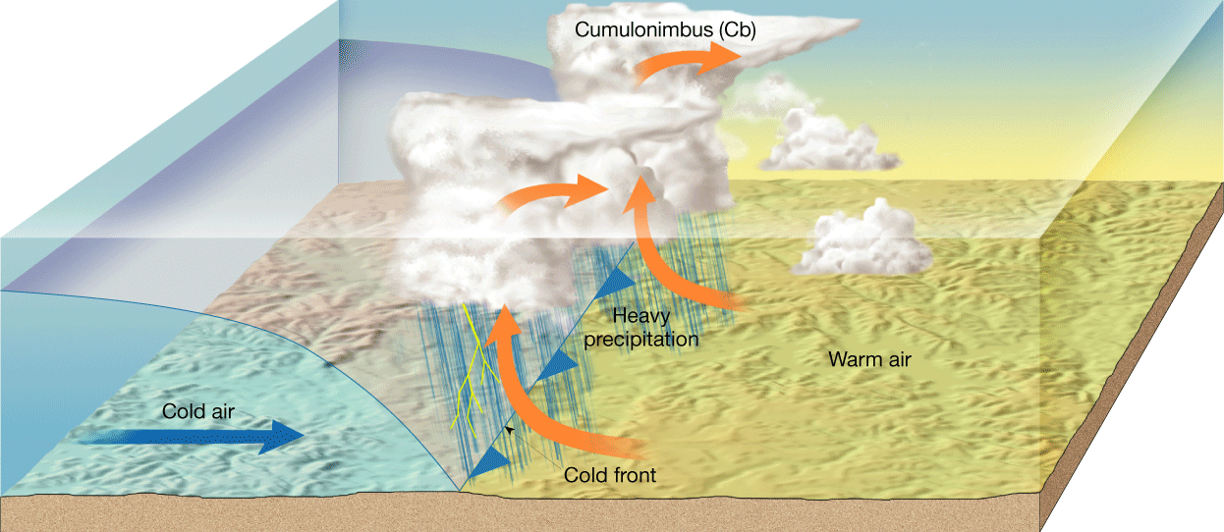
Warm
Occluded
Stationary

- Compare and contrast low and high pressure systems. (2 points)

- _______________________________________are small particles in the atmosphere around which cloud droplets can form.

- _________________________________________occurs when wind encounters a mountain and the air has no place to go but up.

- Describe coalescence.

- What three things are required for a thunderstorm to occur? (3 points)

- What is the most dangerous stage of a thunderstorm? ________________________(2 points)

  - What can occur during it?

- Thunderstorms usually form along ________________fronts and are associated with ____________pressure systems.
- Describe lightning and thunder. (2 points)

- A violently rotating column of air that usually touches the ground is a _____________________.
- What is the difference between a tornado watch and a tornado warning? (2 points)

- Whirling tropical cyclones that produce winds of at least 119 kilometers per hour are known in the United States as _______________________.
- What is the calmest part of a hurricane? ____________________
- What is the difference between a hurricane watch and a hurricane warning? (2 points)

- What are the three characteristics of a blizzard? (3 points)

